Personal Jesus - Johnny Cash

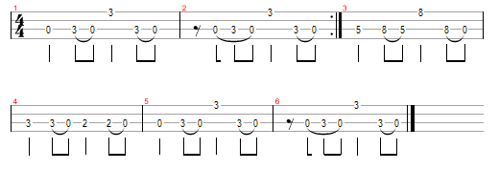
Refrain | Cm | Cm | Cm | Cm | Cm | Cm | Fm | D# / D7

Couplet | Cm | Cm | Fm | D# | Fm | Cm/D# | Cm | Cm

Pont | Fm | D# | Cm | Cm | Fm | D# | Cm | Cm
Outro | D | Fm/ D# | Cm | Cm | D | Fm/ D# | Cm | Cm

Cm
Your own personal jesus
Cm
Someone to hear your prayers
Fm D# D7
Someone who cares

Cm
Your own personal jesus
Cm
Someone to hear your prayers
Fm D# D7
Someone whos there

Cm
Feeling unknown
Cm
And youre all alone
Fm
Flesh and bone
D#
By the telephone
Fm
Lift up the receiver
Cm D# Cm
Ill make you a believer

Cm
Take second best
Cm
Put me to the test
Fm
Things on your chest
D#
You need to confess
Fm
I will deliver
Cm D# Cm
You know Im a forgiver

Fm D# Cm
Reach out and touch faith

Reach out and touch faith

Cm
Your own personal jesus
Cm
Someone to hear your prayers
Fm D# D7
Someone who cares
Cm
Your own personal jesus

Cm
Someone to hear your prayers
Fm D# D7
Someone whos there

Cm
Feeling unknown
Cm
And youre all alone
Fm
Flesh and bone
D#
By the telephone
Fm
Lift up the receiver
Cm D# Cm
Ill make you a believer

Fm
I will deliver
Cm D# Cm
You know Im a forgiver
D Fm D# Cm
Reach out and touch faith
D Fm D# Cm
Reach out and touch faith
D Fm D# Cm
Reach out and touch faith
D Fm D# Cm
Reach out and touch faith

